Fall 2020

CNS180

Introduction to Systems Development
Assessment R

Date:

Student Name | Student ID

Feedback/Comments:
S | Topic | Max Points | Earned Points | Feedback
1 | Task 1 | 20
2 | Task 2 | 25
3 | Task 3 | 20
4 | Task 4 | 5
5 | Task 5 | 20
6 | Task 6 | 10
 | Bonus | 5

Total Grade
100

Task1. (10 pts each *2 = 20 pts)

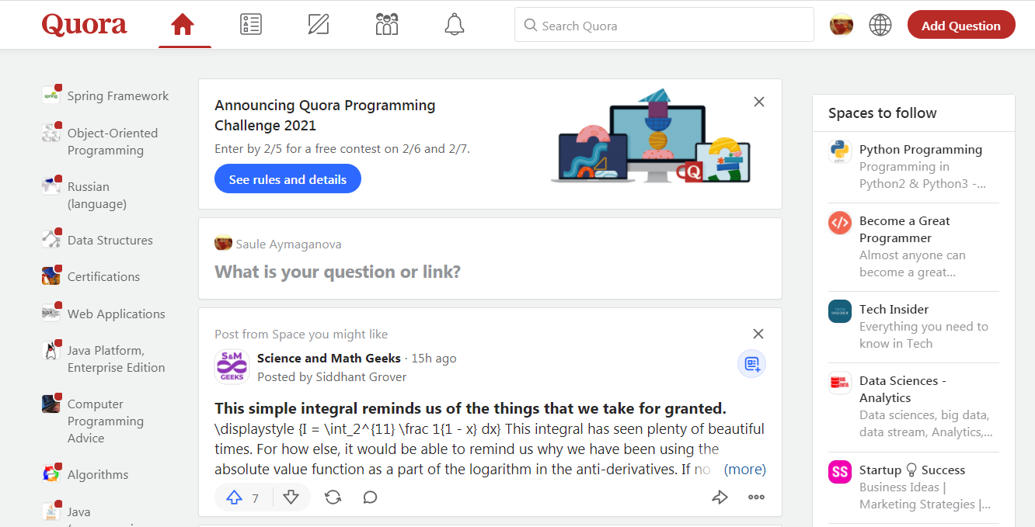
www.Quora.com
Quora is an American question-and-answer website where questions are asked, answered, followed, and edited by Internet users, either factually or in the form of opinions.
The company was founded in June 2009. In 2020, the website was visited by 590 million unique people a month.
Analyze this web-site, create login, try to follow some spaces, and read popular questions and answers. Try to make your own search for the question that interests you.

a) In chapter 1 you have learned about 5 components of the system. Describe the 5 components of the system for Quora: Data, People, Hardware, Software, Processes.

Solution:
Hardware is the most common part of a computer based information system. Hardware is the computers themselves along with any and all peripherals involving servers, routers, monitors, printers as well as storage appliances
Software aids in gathering, organizing as well as organizing data and carried out instructions.
Data refers to the information part of an information system and if it is the statistical data, sets of instruction.
Information systems involve people who develop softwares and hardware, input the data and keeps it running, develop procedures and later they are the ones that determine the effectiveness of a system.
Processes are the rules, descriptions as well as instruction of how things are done. This mainly involves the use manual which describe the usage of hardware, software as well as data.

b) In chapter 1 you have learned about 5 IS categories. How do you think, which category belongs Quora? Explain your opinion.

Solution:
Quora is a transaction processing system which is used to process data generated by the client. Quora aids in providing high performance, data correctness as well as the ease of use. The application processes the client’s needs and provides a response to the clients based on the request.
Task2: (5*5 = 25 pts)
You need to describe system requirements for Quora. Describe 3 requirements for each requirement category (Input, Output, Process, Performance, and Security):

 | Input:
1. | Any user can feed data into the system
2. | A user should have a signed in account
3. | The web site must report online volume statistic each hour
 | Output:
1. | The system provides response based on a user’s question
2. | The responses should be more than three
3. | The responses should be available on time for making good decisions
 | Process:
1. | The system must automatically produce the best three responses
2. | They system should automatically group the responses based on the topic where the topic belongs
3. | They system should not accept questions or answers from those who do not have an account
 | Performance:
1. | The system should be operational every time 24-7
2. | The system must support all users simultaneously
3. | The response time must not exceed more than four seconds
 | Security:
1. | A user must have an account
2. | The system must maintain separate levels of security for users as well as the system administration.
3. | The system should create an error log file which involves the error type, description as well as time.

Task 3. (20 pts)
Given Class diagram. Draw object diagram on paper. Create a customer Abzal(his name is Abzal). He
made 2 orders. First order contain Juice and Popcorn. Second order contains Chocolate bar and
Milk. (Other details you can add yourself.)
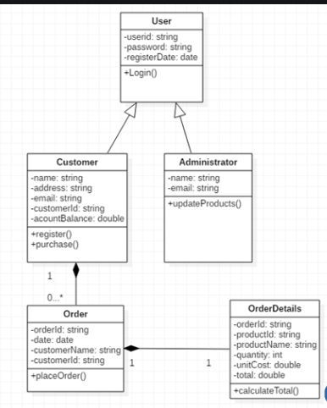
Solution:

Userid-6
Password=wwe34
RegisterDate=11/1/2020

Customer ID= 1
Name=Abzar
Address=London
Email=abzar@gmail
Account balance= 20
Purchases

Order=12
Date=11/1/2020
Customername= Abzar
Customerid=1
Orderid= 11
Date=11/1/2020
Customername= Abzar
Customerid=1

Orderid=12
Productid=32
productName=chocolate bar and milk
quantity=5
UnitCost=50
Total=250
Orderid=11
Productid=31
productName=Juice and Popcorn
quantity=3
UnitCost=40
Total=120

Orders Orders
Task4. (5 pts)
Given class diagram for animal. Draw object diagram:

Book
Author
Title
Price
Number of pages
Buy()
Read()

Solution:

Animal
+age: Int
+gender: String
+isMammal ()
+mate()

Task5. (20 pts)
Given class diagram, draw object diagram for below use-case (story) Draw on paper, and post it below.

Use-case (Story):
There two camp Sites: Green Island, and Ahmadi Zoo. 3 camping Trips: two of them to the Green Island, and one of them to the Ahmadi Zoo.
There are 2 Scouts: Alima (she is normal Scout) and Hamza (he is Wealthy Scout, he donated 2000 KD).
Alima has only one awarded Badge – that is Beginner badge (e.g. badge specification name: “beginner”).
Hamza has two awarded badges - Beginner Badge, and Canoeing Badge.

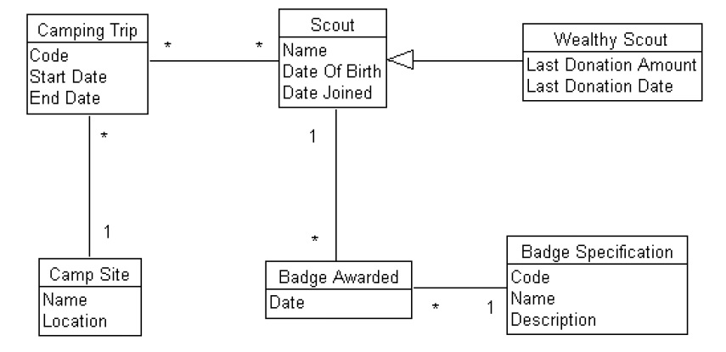

Solution:

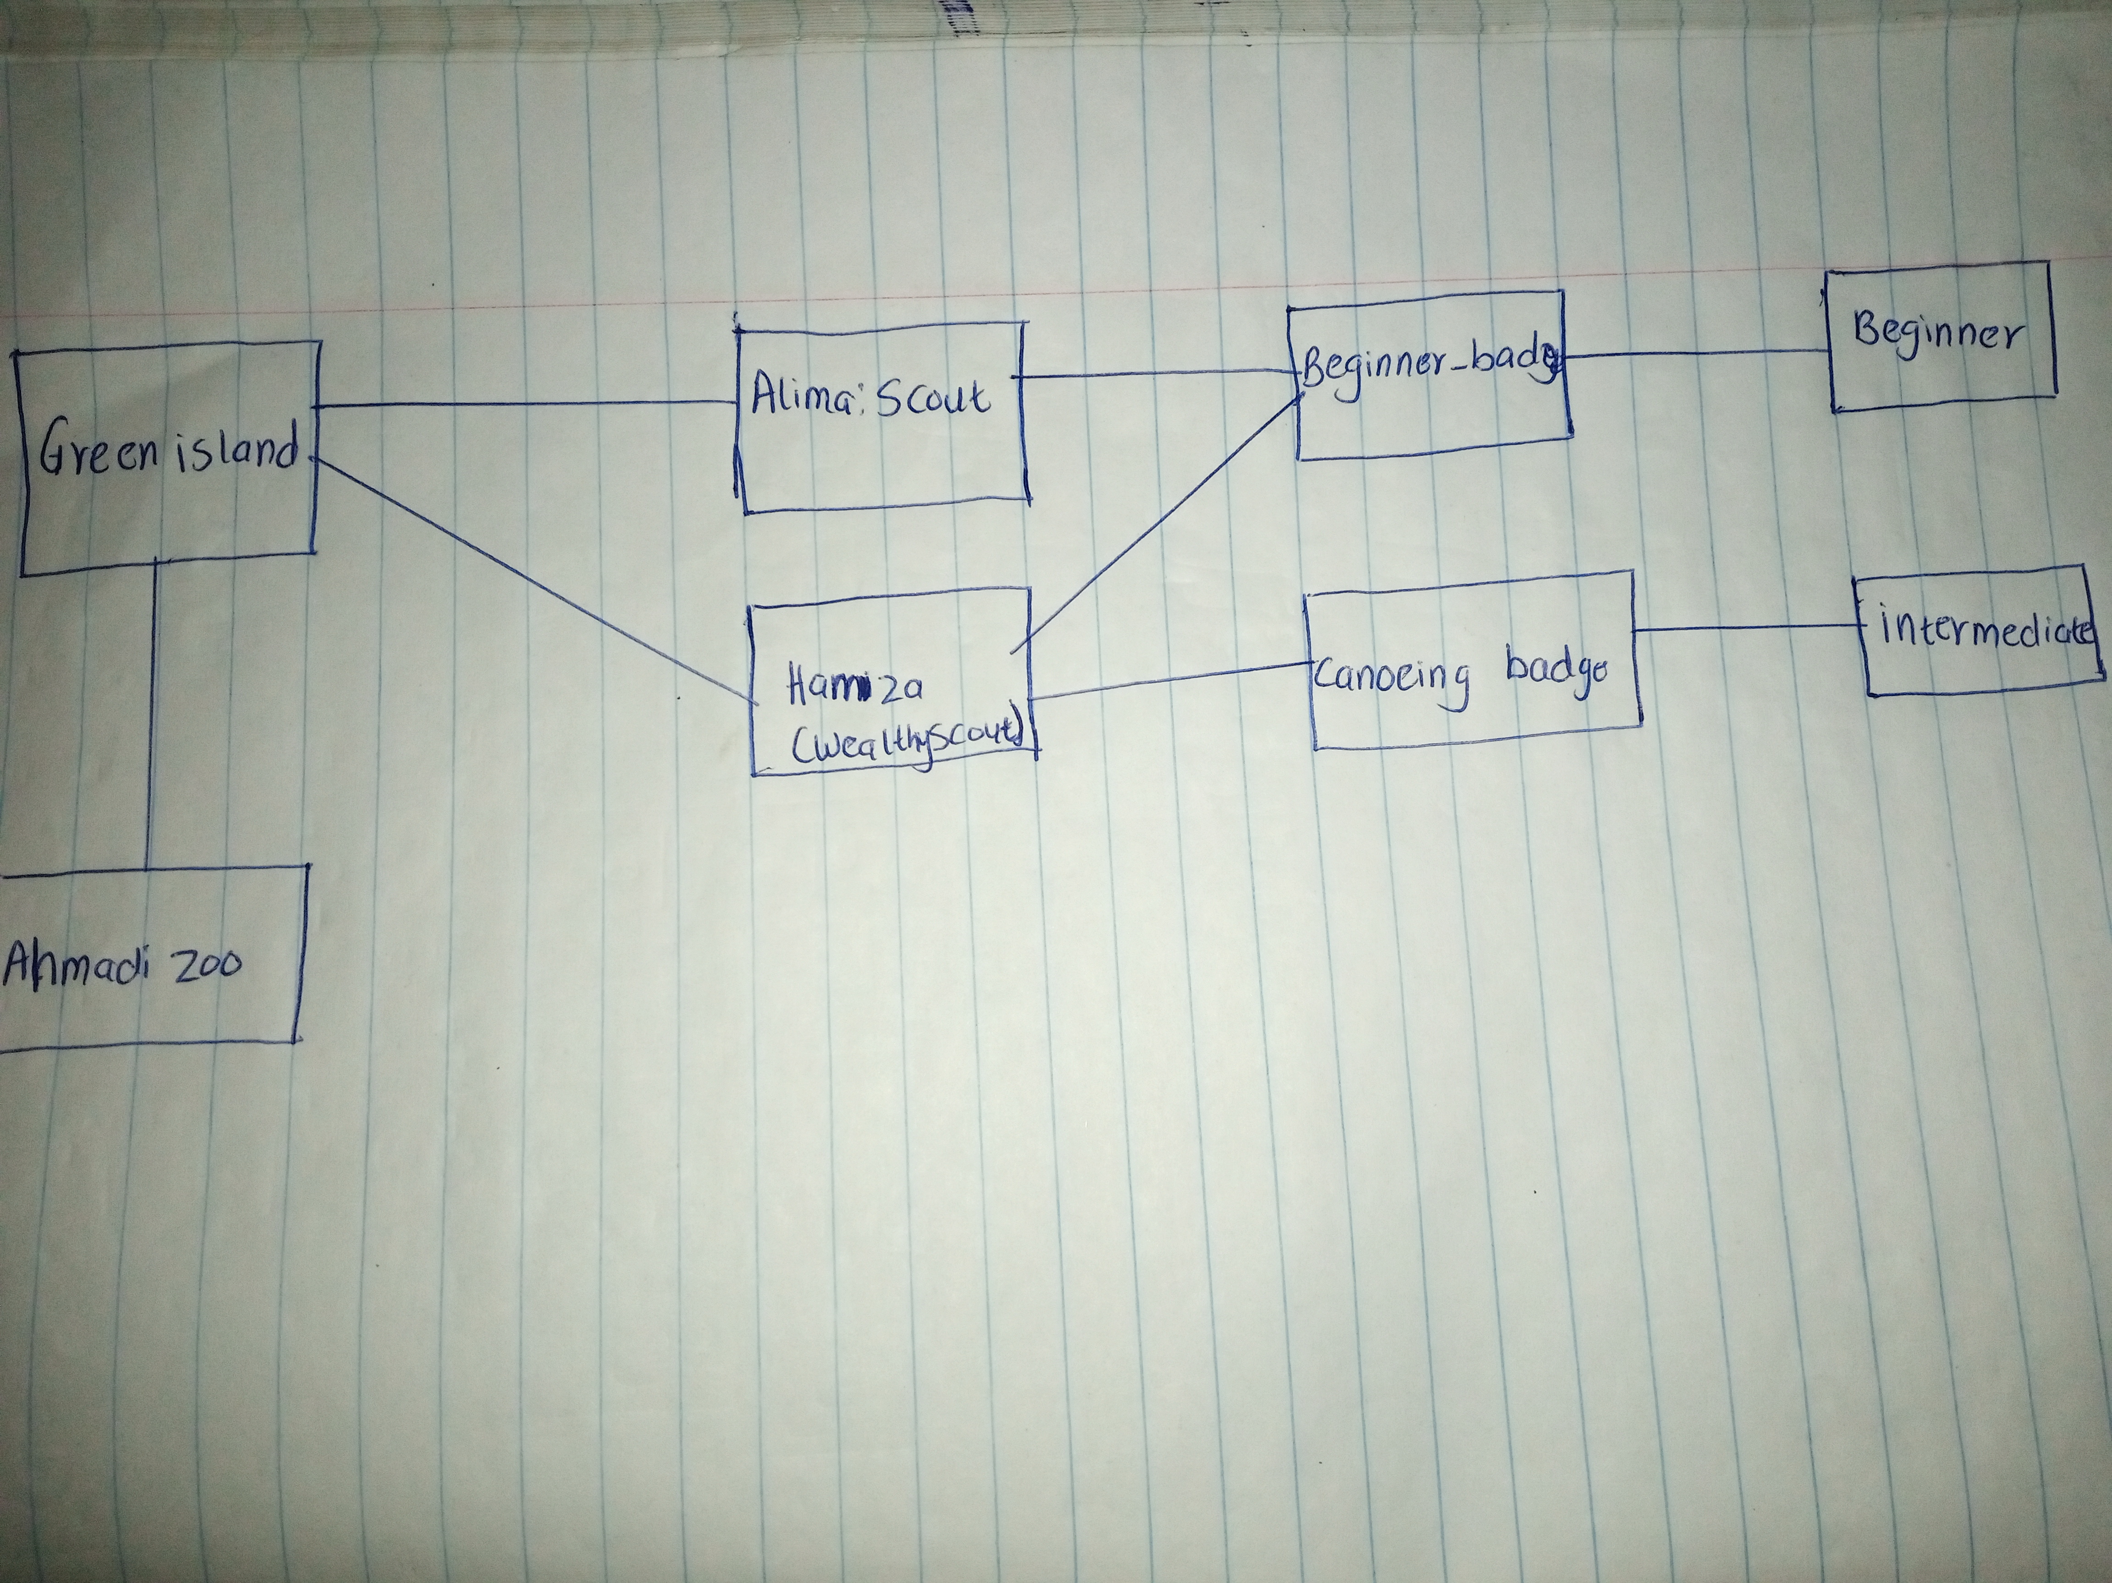
Task 6 (5 pts each * 2 = 10 pts)
a) Draw activity diagram for a process: How to add question in Quora. There are many options available in Quora: question type – public, anonymous, etc., including link to the question, share Link, etc.
Login
Home page
Add questions
Type the question
Invite people to answer
Post the question

b) Explain your activity diagram.

Solution:

When your login at quora .com you go to homepage and choose Add question button in the navigation bar, type your question and choose the people you invite to answer the question and finally post the question by selecting add question button there.

Bonus: (5 pts)
Draw the class diagram represented by the following.

Room (Room number, Room type, number of beds, and number of rooms)
Booking (booking id, booking date, Amount to pay, number of days to stay in, room id)
Customer (name, gender, age)

Customer makes booking. Booking reserves a room.
Room
Room Number: int
Room type: string
Number of beds: int
Number of rooms: int

*

1
Bookings
Booking Id: int
Booking date: date
Amount to Pay: int
Number of days to stay: int
Room id: int

*
1
Customer
Name: string
Gender: string
Age: int

